Problems and thoughts

The problems are (following the flow):
- The button "Check in global watchlist" have to be seen only by the customers who have paid for that. For this one i thought to insert “manually” the button, under determinate condition as follow in dynamic-form.component: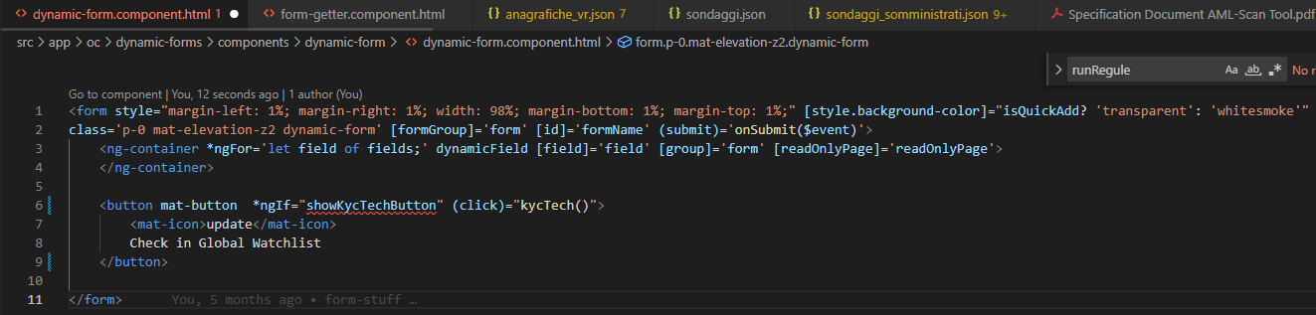

or in the menu.component:

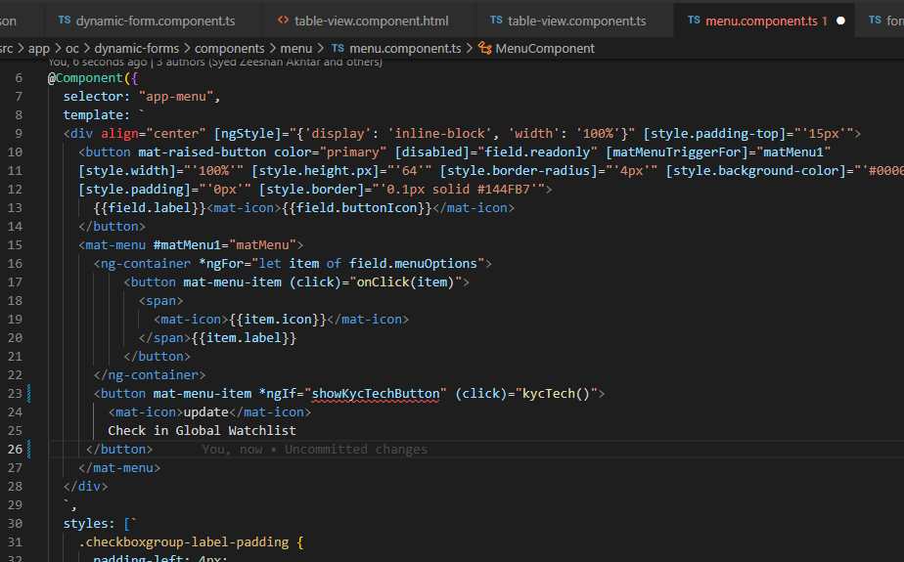

But I like more to wrote into the view’s json, so we have to find a way to hide the button when it has to be.

- Once I have more than one registry (person or company) to scan with regulat.io tool, since with this tool I can’t post more than one at time, we must launch more time the post. So in the follow example, I have to launch the post 1(the original) + 6 times (of which 3 in “person mode” and 3 in “company mode”)
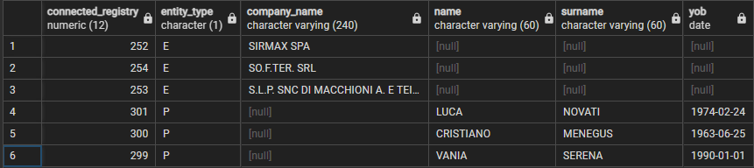
So the question is, when should we cycle the procedure?
In form-getter? We should call backendService.getAmlScan more times, I don’t think so.
In index.js of regulat lambda? I think so! So here I wrote a for loop over the array connectedRegistries (which is passed by the backendService.getConnectedRegistries).

- Store correctly the response data in the variable scannedData of lambda which will be passed as a payload in regulat_VPC lambda which will process it. Another related problems are:
- Add to the payload of lambda.invoke another parameters, request_type = ‘getAmlScan’.
- Add to the scannedData the key-value of company,registry and checkId which are passed by the frontend.
Below in regulat lambda:
